Universidad de Cundinamarca
Lengua Extranjera II

Lesson 3 - Chapter 3: The Fisherman and his Wife

Cristian Esteban Ruiz Parra

30 de septiembre de 2025

COMPREHENSION QUESTIONS
- What did King Acrisius have made?
- He had a large coffin made.
- What reason did the King give Danae for doing what he did?
- He said that her child was a killer who would one day kill him.
- Who was watching over the coffin?
- Zeus was watching over the coffin.
- How did the coffin get onto the beach?
- A great wave lifted it high in the air and carried it to the beach.
- What was Dictys’s reaction when he broke open the coffin?
- He was surprised and did not know what to think when he saw a woman and child inside.
- How did Danae feel after the journey?
- She felt hungry and tired.
- Where will Danae and Perseus stay?
- They will stay with Dictys and his wife for as long as they wished.
- Why did Danae like living on the island?
- Because everything seemed easy and quiet there.
TOPICS FOR DISCUSSION
- Do you think Danae and Perseus will stay on the island?
- Yes, because they found safety and kindness there.
- What’s the worst journey you’ve ever had? What happened?
- I haven't had any bad trips because I don't travel much.
- Who’s the kindest person you’ve ever met?
- The kindest person I know is my grandmother, she is a person who helps and prays for everyone.
- Have your parents taught you any skills? What are they?
- My mother teaches me to cook
ACTIVITIES
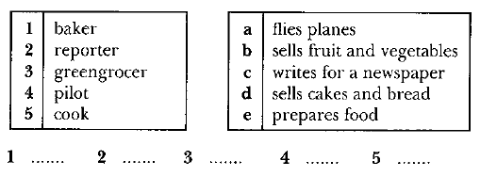

- _d_
- _c_
- _b_
- _a_
- _e_

- Write Dictys’s account of how he found Danae and Perseus.
One day, Dictys was on the beach when he saw a large coffin come out of the sea. He broke it open and was surprised to find a woman and a child inside. They were Danae and her son, Perseus. They were hungry and tired after their long journey. Dictys, being a kind man, took them to his home. He and his wife offered them food and a place to stay. They told Danae and Perseus they could live with them for as long as they wished, and they began to live together like a family.
VOCABULARY EXERCISES
- Choose the correct word.
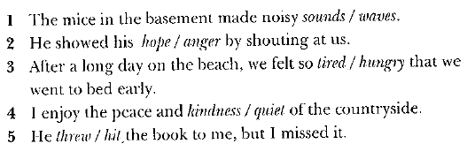
- The mice in the basement made noisy _sounds_.
- He showed his _anger_ by shouting at us.
- After a long day on the beach, we felt so _tired_ that we went to bed early.
- I enjoy the peace and _quiet_ of the countryside.
- He _threw_ the book to me, but I missed it.
- Fill in the correct word(s) from the box.

- to _be_ on my own
- to _hold_ sb in my arms
- to _bring_ sb to land
- to _reach_ a place
- to _keep_ sb away from sb/sth
- Fill in the correct form of the words in capitals.
- After a lot of hard work, he _finally_ became very successful.
- His rude behaviour made me very _angry_.
- You must always treat animals with _kindness_.
- She was quite _disappointed_ when she failed her test.

